RESEARCH PROPOSAL
MSc in Geography & Environmental Studies

VERY HIGH RESOLUTION REMOTE SENSING OF PORTULACARIA AFRA CANOPY COVER
DUGAL HARRIS (MSC ELEC ENG)
(17447585)

SUPERVISOR: DR A VAN NIEKERK
Department of Geography & Environmental Studies
Stellenbosch University

12 MAY 2012

DEPARTMENT OF GEOGRAPHY AND ENVIRONMENTAL STUDIES

BACKGROUND
Portulacaria afra (Spekboom) is an evergreen succulent tree growing to 2.5m, with small fleshy leaves. It occurs in the Subtropical Thicket biome and is the dominant species in the arid and valley thicket habitat types (Vlok, Cowling & Wolf 2005). “The Subtropical Thicket habitat types are most easily recognized by the occurrence of woody trees, spinescent shrubs and a relative abundance of succulents. When occurring as solid stands the vegetation can form impenetrable dense thickets, but this is uncommon in the Little Karoo. In most of the area the Subtropical Thicket vegetation occurs as discrete bush-clumps, usually in a matrix of Succulent Karoo vegetation” (Vlok, Cowling & Wolf 2005: 41). While P. afra is tolerant of browsing by indigenous herbivores, it is highly susceptible to over browsing by goats (Marais, Cowling & Powell 2009; Sigwela et al. 2009; Mills et al. 2007; Mills et al. 2005). Poorly managed goat grazing transforms thicket into sparsely scattered thicket clumps, isolated trees and a covering of herbs (Mills et al. 2005). Figure 1-1 shows an example of degraded and intact P. afra thicket across a fence-line in the south-eastern Cape. Once thicket has been severely degraded, removing grazing pressure does not result in natural recovery (Mills et al. 2007; Vlok, Cowling & Wolf 2005).
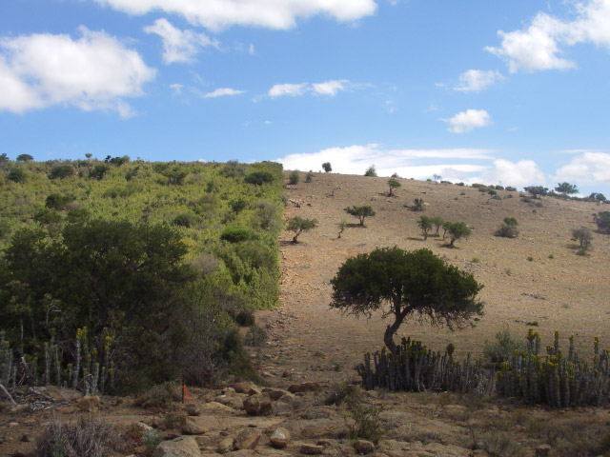
Figure 1-1 Intact and degraded subtropical thicket
Source: (Restoration Research Group 2012)

There is considerable interest in actively restoring degraded thicket habitat for several reasons. P. afra is unusually effective at storing carbon compared to other arid region vegetation. The average rates of carbon storage have been measured at two restoration sites as 4.2 ± 0.08 t C ha⁻¹ yr⁻¹ and 1.2 ± 0.03 t C ha⁻¹ yr⁻¹ (Mills & Cowling 2006). Comparison of degraded and intact sites has shown that restoration could sequester the order of 100 t C ha⁻¹ (Mills et al. 2005; Marais, Cowling & Powell 2009). These numbers compete with the carbon storage capacity of mesic forests (Mills et al. 2005). Carbon captured through restoration of P. afra can be traded as credits on the international carbon market. Using this as a source of funding for landscape-scale restoration is economically viable at current carbon prices (Mills et al. 2007; Marais, Cowling & Powell 2009). P. afra has the uncommon ability to switch between C3 and CAM photosynthetic systems depending on season (Guralnick & Ting 1986). This means it is productive year-round which likely contributes to its substantial sequestration abilities (Mills & Cowling 2010). P. afra propagates vegetatively and can thus be grown from cuttings (Stuart-Hill 1992) which means that costs of restoration can be reduced by avoiding nursery expenses (Mills & Cowling 2010). Subtropical Thicket provides an important source of food for many herbivores, including domesticated livestock (Thompson et al. 2009; Vlok, Cowling & Wolf 2005). Re-establishment of P. afra in degraded areas will help prevent soil erosion and reduce flood severity (Mills & Cowling 2006). It is also attractive from an employment perspective; potentially creating thousands of jobs in impoverished areas, if implemented on a large scale. Increased biodiversity could help improve income from tourism and provide sustained access to wood, fruit, and medicines for local communities (Mills et al. 2007).

It is thought that the dense canopy of P. afra facilitates an accumulation of soil organic matter which in turn improves the water-holding capacity and fertility of the soil (Mills & Cowling 2010; Lechmere-Oertel et al. 2008; Mills & Fey 2004). This, in addition to increased rain run-off round the canopy perimeter, seems to create a favourable environment for other plants to grow (Mills & Cowling 2010). It has been observed that over a period of 40 years, woody canopy and other species re-establish in P. afra restoration areas to a degree that restored thicket is compositionally identical to intact thicket (Vyver et al. 2012). An investigation into the feasibility of accelerating the restoration of woody canopy species through planting in P. afra restoration sites was conducted, but it was found that survival rates were poor and restoration costs prohibitive (Vyver et al. 2012). It seems the most practical option for ecosystem restoration is to plant P. afra and allow other species to re-establish naturally through spontaneous recruitment (Mills et al. 2007).

Restoration research is being conducted as part of the Subtropical Thicket Restoration Project (STRP), which is an initiative of the Working for Woodlands Programme. “To evaluate methods of spekboom restoration, a partnership has been forged among scientists, government and an implementing agency. The South African government’s Working for Woodlands Programme … has engaged a group of scientists to assist in evaluating effective ways of using spekboom cuttings for restoration under different conditions …. The programme is being managed by an implementing agency, the Gamtoos Irrigation Board (GIB), rated as one of the best agencies used by Working for Water.” (Mills et al 2010: 9) P. afra restoration is also actively being conducted and monitored in the Baviaanskloof Nature Reserve, Addo Elephant National Park and the Fish River Reserve in the Eastern Cape (Mills et al. 2010). Approximately 1630 ha have been restored in these areas to date (Vyver et al. 2012).

Supporting spatial information is needed to aid the P. afra restoration process. Candidate restoration areas need to be identified. There are many factors to consider when selecting appropriate sites (Curran et al. 2012; Knight et al. 2011). A map of P. afra canopy cover is a key input to this decision-making process. Canopy cover can be used to estimate the expected carbon storage resulting from restoration. This provides an indication of the economic feasibility of restoration. Measures of intact canopy cover in a similar habitat to the restoration area are used to determine an appropriate planting density. Restoration progress can be monitored by updating the canopy cover map over time which would also assist in the carbon accounting required for trading credits on the international market (Mills et al. 2010). The canopy cover map would also be a useful tool for deepening the present understanding of the Subtropical Thicket biome.

A detailed vegetation map of the Little Karoo has been created at a 1:50000 scale (Vlok, Cowling & Wolf 2005). Using this map, a degradation mapping study was conducted in the Little Karoo (Thompson et al. 2009). It was successful at using MODIS data to estimate intact, moderate and severe degradation levels of P. afra thicket. Currently, there is an initiative to involve private land-owners in the restoration project in order to broaden its impact (Curran et al. 2012; Mills et al. 2010). Restoration planning at farm-level will require map scales of 1:10000 or better to provide sufficient spatial detail for working with expected stand sizes of the order of 50 hectares. To achieve sufficient accuracy for carbon storage estimations, it will be necessary to estimate canopy cover in finer detail than the three levels of degradation used in Thompson et al. (2009). There is thus a need to further the work of Thompson et al. (2009) to produce maps of both a higher spatial and canopy cover level resolution.

PROBLEM STATEMENT
Habitats supporting P. afra have been degraded by overgrazing over much of their range. There is significant interest and a growing body of research in P. afra restoration. Restoration projects will generate employment, restore ecosystem services and produce carbon credits that can be traded to offset restoration costs. There is a need for spatial information, in the form of P. afra canopy cover maps, to support restoration projects in the identification of suitable areas to plant and in the monitoring of restoration progress at repeated intervals. Restoration is planned for large areas of the Little Karoo and Eastern Cape. Map scales of at least 1:10000 are required to provide sufficient accuracy for farm-level restoration planning.

AIM(S) AND OBJECTIVES
The research aim is to develop an automated or semi-automated image analysis technique to accurately estimate P. afra canopy cover in pristine and transformed areas from very high resolution (VHR) remotely sensed imagery, covering large areas.
To achieve the research aim, the following objectives have been set:
- Perform a literature survey covering P. afra restoration, vegetation and canopy cover mapping in arid environments and vegetation and canopy cover mapping using VHR imagery.
- Perform a field study to establish a number of two ha reference sites, across a variety of thicket types and regions. Determine the ground truth canopy cover for each site.
- Source and rectify raw imagery from National Geo-spatial Information (NGI). Investigate appropriate calibration methods for achieving spatial and temporal radiometric consistency.
- Develop a classifier that distinguishes P. afra from surrounding vegetation. Determine P. afra canopy cover from the classification results.
- Apply the canopy cover estimation technique to imagery of the Little Karoo and interpret the results. Conduct a second field study to validate and measure the accuracy of the results.

SIGNIFICANCE AND RATIONALE
Measures of canopy cover can be used to infer biomass for individual species (Ludwig, Reynolds & Whitson 1975). In the context of climate change, biomass is an important variable for monitoring ecosystem carbon dynamics. Carbon absorbed by vegetation and soils will play a significant role in efforts to reduce atmospheric CO₂ and in determining the development of future climate change (Eisfelder, Kuenzer & Dech 2012; Lu 2006). Canopy cover or biomass is also important from a perspective of understanding environmental processes and ecosystem services. Improved biomass is related to increased biodiversity (Lu 2006; Fabricius, Burger, and Hockey 2003), reduced erosion and improved soil fertility and water-holding ability (Eisfelder, Kuenzer & Dech 2012; Mills & Cowling 2010; Lechmere-Oertel et al. 2008; Mills & Fey 2004).

Under the Kyoto Protocol, ratified countries are legally bound to reduce CO₂ emissions to capped levels. If these levels are exceeded, countries can make up the deficit by buying carbon credits from another country that was able to reduce its emissions below its target level (Mills et al. 2010). The Clean Development Mechanism (CDM) is a means by which developing countries can run sequestration projects and trade carbon credits on the international market. There are also the Voluntary Carbon Standard (VCS), Community, Climate and Biodiversity Standard (CCBS) which work on a similar basis to the CDM, but don’t require authorisation by the host country. Under these schemes there are legal provisions that require rigorous accounting of stored carbon. These measurements are time consuming and costly when performed manually (Eisfelder, Kuenzer & Dech 2012; Lu 2006). Canopy cover measurements are currently being done by visual inspection in the field. There is a need for greater accuracy and repeatability than is possible with this technique. A P. afra canopy cover map would serve as a first step towards achieving the required carbon storage measurements via remote sensing on a large scale.

The benefits of P. afra restoration are manifold and include benefits for local communities. The STRP has placed a strong emphasis on stakeholder engagement and community development (Marais, Cowling & Powell 2009). Restored areas will provide increased capacity for supporting judiciously managed livestock and employment for thousands of workers if restoration is implemented on a large scale (Mills et al. 2010). Employment is particularly relevant for the Eastern Cape where unemployment rates are amongst the highest in South Africa at roughly 27% (Statistics South Africa 2011).

This research presents a number of challenges from a technical remote sensing perspective. There is VHR (0.5m/pixel) multi-spectral data with national coverage available from National Geo-spatial information (NGI) (National Geo-spatial Information 2012). This imagery represents a rich source of information, but to date it has only been used for topographical mapping and photo-interpretation. To the best of the author’s knowledge, this will be the first study to exploit this imagery for automated or semi-automated vegetation monitoring. Use of VHR imagery for estimation of environmental variables is fairly uncommon, especially over large areas such as the Little Karoo (Eisfelder, Kuenzer & Dech 2012; Lu 2006). Figure 4-2 shows an example colour infra-red (CIR) image of P. afra thicket from NGI.

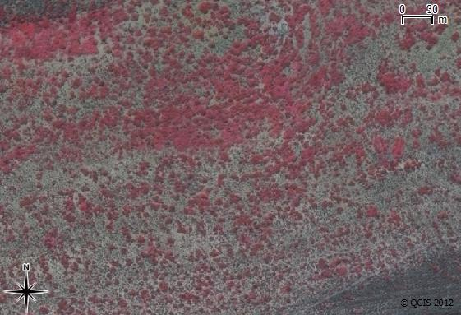
Figure 4-2 CIR Image of P. afra Thicket

Another aspect of this research that has been relatively unexplored in the literature is measuring some aspect of degradation, like canopy cover, in an arid environment. Research on measurement of indicators in forest ecosystems is fairly well established (Lu 2006; Wulder et al. 2004; Lévesque & King 2003). Arid regions present some remote sensing challenges not typically encountered in forests. These include the naturally sparse vegetation cover and mixing of soil and vegetation spectra (Eisfelder, Kuenzer & Dech 2012; Thompson et al. 2009). Arid regions cover roughly one third of the terrestrial land surface (Food and Agriculture Organization (FAO) 1989) and are particularly sensitive to degradation (Mills et al. 2005; Stuart-Hill 1992). Remote sensing techniques applicable to arid environments are therefore of importance.

Dealing with sources of unwanted variation is a recurring difficulty reported in the remote sensing literature (Eisfelder, Kuenzer & Dech 2012; Baraldi et al. 2010; Lu 2006). Achieving an accurate canopy cover mapping over a large spatial scale and using a mosaic of images acquired at different times will require an algorithm that is robust to many of the variations commonly encountered. These will include varying topography and P. afra habitats, phenological changes and shadow variations. Dealing with these challenges is expected to comprise a significant portion of the research effort and results will likely be of interest to the remote sensing community.

RESEARCH METHODOLOGY
Canopy cover measurements are currently being conducted manually by visual inspection in the field. While this is a common approach for measuring environmental indicators, it is time consuming and only practical for small areas (Eisfelder, Kuenzer & Dech 2012; Lu 2006). A visual inspection is also prone to repeatability issues due to the subjectivity of the inspector. P. afra restoration is envisioned for large areas of the Eastern Cape and Little Karoo and will require monitoring of plant growth over time. Repeatability and accuracy constraints on carbon measurements will be stringent in order to achieve the necessary accreditation for carbon trading in schemes like the CDM. This research will follow a quantitative remote sensing methodology. This approach is common for biomass estimation (Eisfelder, Kuenzer & Dech 2012; Lu 2006) and is chosen as it will facilitate accurate canopy cover estimation of large areas and at repeated intervals.

An empirical methodology will be used for developing the canopy cover estimation. Various secondary measurements or features will be extracted from the remotely sensed data and used to build a model of P. afra canopy cover. Similar approaches for measuring degradation or biomass in an arid environment were successful in Thompson et al. (2009) and Ludwig, Reynolds & Whitson (1975). The accuracy of the model will be tested against unseen data as a check against overfitting (Jain, Duin & Mao 2000).

This work is intended to be applied research. Emphasis will be placed on producing a map that is both useful and usable (Pierce et al. 2005). This will require interaction and communication with stake-holders (Knight et al. 2011), specifically environmental practitioners currently involved in performing canopy cover assessments, the STRP and the GIB, who are the restoration implementing agents (Mills et al. 2010).

There is a tendency for environmental remote sensing to be conducted in an isolated way that does not allocate adequate importance to understanding complex human and ecological processes affecting the data being analysed (Hein et al. 2011; Turner 2003). This naïve approach can lead to models that do not generalise well over varying spatial and temporal conditions. Recognition of the value of multi-disciplinary teams incorporating expert knowledge of local conditions and field experience is given in Knight et al. (2011) and Thompson et al. (2009). This research will be undertaken in collaboration with a botanist, Jan Vlok, who has a wealth of experience in the Little Karoo (Thompson et al. 2009; Forsyth, Vlok & Reyers 2008; Vlok, Cowling & Wolf 2005) and with P. afra in particular. It is envisioned that his insight into local habitat variations and ecosystem behaviour will be invaluable to this research.

RESEARCH METHODS

Study Area
The study area is the Little Karoo as shown in Figure 6-3 and defined in Vlok, Cowling & Wolf (2005). The Subtropical Thicket biome makes up 35.3% of the Little Karoo which has a total area of 2 343 900 ha (Vlok, Cowling & Wolf 2005). It was found that 89.3% of the P. afra thicket was degraded to some extent in a study area comprising roughly half the area of the Little Karoo (Thompson et al. 2009). The Little Karoo was chosen as a study area because it contains a significant portion of P. afra suited and degraded habitat and has been targeted for restoration. It is also beneficial that a number of relevant studies have been performed in the area (Thompson et al. 2009; Forsyth, Vlok & Reyers 2008; Vlok, Cowling & Wolf 2005). While the maps produced by these studies are not at a 1:10000 scale, they will nevertheless prove useful to this research as a source of ancillary data and a means of conducting coarse validation tests.

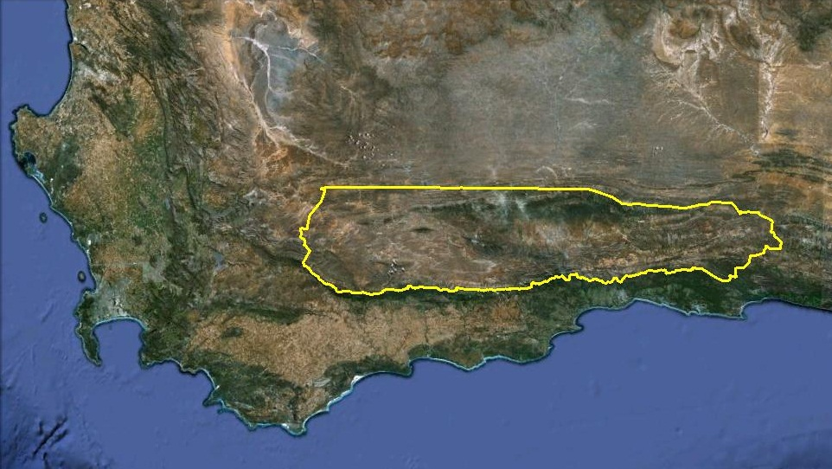
Figure 6-3 Little Karoo study area

Field Study and Ground Truthing (Objective 2)
In collaboration with Jan Vlok, a number of field sites will be identified. These sites will be of the order of two ha in area and should encompass the various thicket habitat types and levels of degradation. Canopy cover ground truth will be established for each site using the current system of visual inspection as well as by manual delineation of P. afra canopy in aerial images. To achieve a robust, transferable model, it is desirable for these study sites to represent as much habitat and degradation variation as possible. The extent of the field work will be limited by time, accessibility and available funds.

Image Calibration (Objective 3)
Imagery available from NGI in an orthorectified form contains only three of the four available bands and exhibits radiometric inconsistencies. It is not suitable for large scale remote sensing analysis in this form. The imagery will thus be sourced in a raw four band format and orthorectified using the existing aero-triangulation information from NGI with standard software. A benefit of performing the rectification is that a digital surface model (DSM) or height map can be constructed in conjunction with this procedure (Zhang & Gruen 2006). This DSM would contain coarse plant height information which could prove useful as feature or ancillary data for the canopy cover mapping algorithm.

Radiometric consistency of the Little Karoo orthorectified image mosaic will be visually and quantitatively evaluated. The raw NGI data has been corrected for camera effects, and atmospheric effects are expected to be small due to the low flight altitude and selection of clear days for surveying (National Geo-spatial Information 2010). However, it is expected that correction for viewing geometry will be required. Some success in the correction of bidirectional reflectance distribution function (BRDF) effects in large VHR image mosaics has been reported (Collings et al. 2011; Laliberte et al. 2011; Chandelier & Martinoty 2009; Lelong et al. 2008). Available calibration techniques will be researched and applied as appropriate.

Canopy Cover Mapping Algorithm (Objective 4)
The 0.5m/pixel NGI imagery has the advantage of making individual trees and clumps of P. afra resolvable. The canopy cover mapping algorithm will be a two stage process. In the first stage, P. afra trees or tree clumps will be distinguished from the surrounding vegetation. As we expect a wide diversity of surrounding vegetation, a one class classification approach seems appropriate (Tax & Juszcak 2003). A comprehensive feature study will be conducted. Particular attention will be given to texture features in an attempt to make the most of the high spatial resolution. Vegetation indices commonly used for biomass and degradation estimation will be included (Eisfelder, Kuenzer & Dech 2012; Thompson et al. 2009; Lu 2006) as well as ancillary data such as slope orientation and plant height from the DSM. The discriminative power of various feature sets will be evaluated with feature space visualisations and separability measures including classifier performance. In conjunction with the feature study, feature selection and dimensionality reduction techniques will be evaluated for their effectiveness (Jain et al. 2000).

The second stage of the canopy cover mapping algorithm will simply be to evaluate the ratio of identified canopy to surrounding area. Sloping terrain will tend to result in an overestimation of canopy cover. A flattening transform will need to be used in conjunction with a DSM to correct for this effect.

The NGI aims to complete national surveys every 3 years which means that their survey interval is significantly longer than commercially available VHR satellite imagery such as WorldView and Ikonos. This aspect has some drawbacks for the restoration work. Using image time series to describe phenological variations of vegetation is not possible with NGI data. This kind of approach can be useful for distinguishing different vegetation types and for measuring degradation (Hein et al. 2011; Thompson et al. 2009). Fortunately P. afra is evergreen which makes this less of a concern for this study. The NGI survey interval also places limitations on the frequency of restoration monitoring. Techniques developed through this work would however be applicable to similar aerial or satellite imagery i.e. other image sources could be exploited if necessary.

Application (Objective 5)
A canopy cover map will be produced for the Little Karoo using the developed methods. This map will be interpreted in collaboration with Jan Vlok. Intact P. afra canopy covers for various regions and habitat types will be extracted. The intact covers will be used to create a degradation index for transformed areas e.g. what portion of intact cover is occupied by the current canopy cover. This will give an idea of the restoration potential for the area as a whole. Results will be validated through visual photo-interpretation and inspections of randomly selected sites.

LINKAGES OF STUDY TO DEPARTMENTAL PROGRAMMES
This research forms part of a larger research programme in the Department of Geography and Environmental Studies in the use of geographical information technologies (GIT) for sustainable land management decision support. It will be undertaken in collaboration with a botanist, Jan Vlok, who has a wealth of experience in the Little Karoo and is currently involved in P. afra restoration. It is also strongly linked to the “Carbon Stabilization Mechanisms in Spekboom Thicket Soils, Eastern Cape, South Africa” and “Thicket-wide Plot Experiment” projects being conducted by the Department of Soil Science.

Timeline and Deliverables

No. | Task Description | Deliverable | Jun-12 | Aug-12 | Oct-12 | Dec-12 | Feb-13 | Apr-13 | Jun-13 | Aug-13 | Oct-13
1 | Literature survey
2 | Field study & ground truthing
3 | Image calibration
4 | Canopy cover mapping | Paper
5 | Application | Map & paper
 | Thesis | Thesis

REFERENCES

Baraldi A, Durieux L, Simonetti D, Conchedda G, Holecz F & Blonda P 2010. Automatic spectral-rule-based preliminary classification of radiometrically calibrated SPOT-4/-5/IRS, AVHRR/MSG, AATSR, IKONOS/QuickBird/OrbView/GeoEye, and DMC/SPOT-1/-2 imagery—Part I: System design and implementation. IEEE Transactions on Geoscience and Remote Sensing 48 (3): 1299-1325.
Chandelier L & Martinoty G 2009. A radiometric aerial triangulation for the equalization of digital aerial images and orthoimages. Photogrammetric Engineering & Remote Sensing 75 (2): 193-200.
Collings S, Caccetta P, Campbell N & Wu X 2011. Empirical models for radiometric calibration of digital aerial frame mosaics. IEEE Transactions on Geoscience and Remote Sensing 49 (7): 2573-2588.
Curran P, Smedley D, Thompson P & Knight AT 2012. Mapping restoration opportunity for collaborating with land managers in a carbon credit-funded restoration program in the Makana municipality, Eastern Cape, South Africa. Restoration Ecology 20 (1): 56-64.
Eisfelder C, Kuenzer C & Dech S 2012. Derivation of biomass information for semi-arid areas using remote-sensing data. International Journal of Remote Sensing 33 (9): 2937–2984.
Fabricius C, Burger M & Hockey PAR 2003. Comparing biodiversity between protected areas and adjacent rangeland in xeric succulent thicket, South Africa: arthropods and reptiles. Journal of Applied Ecology 40 (2): 392-403.
Food and Agriculture Organization (FAO) 1989. Arid zone forestry: a guide for field technicians. [online]. Available from: http://www.fao.org/docrep/T0122E/t0122e03.htm [Accessed May 22, 2012].
Forsyth G, Vlok J & Reyers B 2008. Retention and restoration of the biodiversity of the Little Karoo. CSIR Report No CSIR/NRE/ECO/ER/2008/0118/C. Critical Ecosystem Partnership Fund, CSIR.
Guralnick LJ & Ting IP 1986. Seasonal response to drought and rewatering in Portulacaria afra (L.) Jacq. Oecologia 70: 85-91.
Hein L, de Ridder N, Hiernaux P, Leemans R, de Wit A & Schaepman M 2011. Desertification in the Sahel: Towards better accounting for ecosystem dynamics in the interpretation of remote sensing images. Journal of Arid Environments 75 (11): 1164-1172.
Jain AK, Duin RPW & Mao J 2000. Statistical pattern recognition : A review. IEEE Transactions on Pattern Analysis and Machine Intelligence 22 (1): 4-37.
Knight AT, Cowling RM, Boshoff AF, Wilson SL & Pierce S 2011. Walking in STEP: Lessons for linking spatial prioritisations to implementation strategies. Biological Conservation 144 (1): 202-211.
Laliberte AS, Goforth M a., Steele CM & Rango A 2011. Multispectral remote sensing from unmanned aircraft: Image processing workflows and applications for rangeland environments. Remote Sensing 3 (11): 2529-2551.
Lechmere-Oertel RG, Kerley G, Mills AJ & Cowling RM 2008. Litter dynamics across browsing-induced fenceline contrasts in succulent thicket, South Africa. South African Journal of Botany 74 (4): 651-659.
Lelong CCD, Burger P, Jubelin G, Roux B, Labbé S & Baret F 2008. Assessment of unmanned aerial vehicles imagery for quantitative monitoring of wheat crop in small plots. Sensors 8 (5): 3557-3585.
Lu D 2006. The potential and challenge of remote sensing based biomass estimation. International Journal of Remote Sensing 27 (7): 1297-1328.
Ludwig JA, Reynolds JF & Whitson PD 1975. Size-biomass relationships of several Chihuahuan desert shrubs. American Midland Naturalist 94 (2): 451-461.
Lévesque J & King DJ 2003. Spatial analysis of radiometric fractions from high-resolution multispectral imagery for modelling individual tree crown and forest canopy structure and health. Remote Sensing of Environment 84 (4): 589–602.
Marais C, Cowling RM & Powell M 2009. Establishing the platform for a carbon sequestration market in South Africa: The Working for Woodlands Subtropical Thicket Restoration Programme. In XIII World Forestry Congress, 1-13. Buenos Aires, Argentina.
Mills AJ, Blignaut J, Cowling RM, Knipe A, Marais C, Marais S, Pierce S, Powell M, Sigwela A & Skowno A 2010. Investing in sustainability. Restoring degraded thicket, creating jobs, capturing carbon and earning green credit. Published by Climate Action Partnership, Cape Town, and Wilderness Foundation, Port Elizabeth.
Mills AJ & Cowling RM 2010. Below-ground carbon stocks in intact and transformed subtropical thicket landscapes in semi-arid South Africa. Journal of Arid Environments 74 (1): 93-100.
Mills AJ & Cowling RM 2006. Rate of carbon sequestration at two thicket restoration sites in the Eastern Cape, South Africa. Restoration Ecology 14 (1): 38-49.
Mills AJ, Cowling RM, Fey M, Kerley G, Donaldson J, Sigwela A, Skowno A & Rundel P 2005. Effects of goat pastoralism on ecosystem carbon storage in semiarid thicket , Eastern Cape , South Africa. Austral Ecology 30: 797-804.
Mills AJ & Fey M 2004. Transformation of thicket to savanna reduces soil quality in the Eastern Cape, South Africa. Plant and Soil 265 (1-2): 153-163.
Mills AJ, Turpie JK, Cowling RM, Marais C, Kerley G, Richard G, Sigwela A & Powell M 2007. Assessing costs, benefits, and feasibility of restoring natural capital in Subtropical Thicket in South Africa. In J. Aronson, S. Milton, & J. Blignaut (eds.) Restoring Natural Capital: Science, Business and Practice (The Science and Practice of Ecological Restoration Series), 179-187. Island Press.
National Geo-spatial Information 2012. National Aerial Photography and Imagery Programme [online]. Department of Rural Development and Land Reform (DRDLR). Available from: http://www.ngi.gov.za/index.php/Image-tabs-home/national-aerial-photography-and-imagery-programme.html [Accessed May 22, 2012].
National Geo-spatial Information 2010. Standard for the Acquisition of Digital Aerial Imagery Preliminary Informative Elements. QLAS.SD.2. Cape Town: NGI.
Pierce S, Cowling RM, Knight AT, Lombard AT, Rouget M & Wolf T 2005. Systematic conservation planning products for land-use planning: Interpretation for implementation. Biological Conservation 125 (4): 441-458.
Restoration Research Group 2012. Intact and degraded Spekboomveld [online]. Available from: http://www.r3g.co.za/spekboom.htm [Accessed May 15, 2012].
Sigwela A, Kerley G, Mills AJ & Cowling RM 2009. The impact of browsing-induced degradation on the reproduction of subtropical thicket canopy shrubs and trees. South African Journal of Botany 75 (2): 262-267.
Statistics South Africa 2011. Quarterly Labour Force Survey Quarter 1, 2011. P0211 .Pretoria: Statistics South Africa.
Stuart-Hill G 1992. Effects of elephants and goats on the Kaffrarian succulent thicket of the eastern Cape, South Africa. Journal of Applied Ecology 29 (3): 699-710.
Tax DMJ & Juszcak P 2003. Kernel whitening for one-class classification. International Journal of Pattern Recognition and Artificial Intelligence 17 (3): 333-347.
Thompson M, Vlok J, Rouget M, Hoffman MT & Cowling RM 2009. Mapping grazing-induced degradation in a semi-arid environment: A rapid and cost effective approach for assessment and monitoring. Environmental Management 43: 585-596.
Turner MD 2003. Methodological reflections on the use of remote sensing and geographic information science in human ecological research. Human Ecology 31 (2): 255-279.
Vlok J, Cowling RM & Wolf T 2005. A vegetation map for the Little Karoo. Unpublished maps and report for a SKEP project supported by CEPF grant no 1064410304.
Vyver M, Cowling RM, Campbell E & Difford M 2012. Active restoration of woody canopy dominants in degraded South African semi-arid thicket is neither ecologically nor economically feasible T. O’Connor, ed. Applied Vegetation Science 15 (1): 26-34.
Wulder MA, Hall RJ, Coops NC, Steven E & Franklin SE 2004. High spatial resolution remotely sensed data for ecosystem characterization. BioScience 54 (6): 511-521.
Zhang L & Gruen A 2006. Multi-image matching for DSM generation from IKONOS imagery. ISPRS Journal of Photogrammetry and Remote Sensing 60 (3): 195-211.

